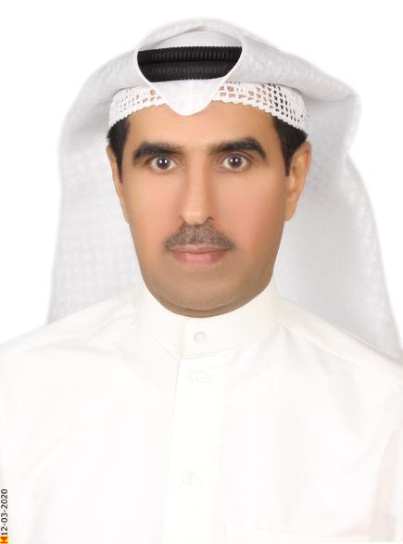 | Bader M. Al Mutairi | 105, Al Sadaf St.  Khobar 31971  Eastern Province  Mobile. +966-550805500  bader.mutairi@yahoo.com

Professional Summary

Results-driven Certified Public Relations Professional with career-long record of corporate communications, business strategy, media and campaign management success for leading organizations

Accomplished, results-oriented Public Relations expert highly regarded for establishing partnerships, generating revenue, utilizing robust analytical skills, and implementing strategic decisions. Dedicated leader with a proven history of image enhancement, innovative advertising, and government affairs management that surpass all expectations. Increases client retention rates by rapidly identifying unique customer needs and establishing rapport. Organized with a keen eye for detail and a demonstrated ability to cultivate effective relations with customers and internal partners, promoting openness, trust, and confidence. Leverages strong communication skills to foster long-lasting relationships with colleagues, clients, and stakeholders. Thrives in fast-paced, collaborative and diverse environments. Expert at creating and implementing media outreach and response strategies.

Core Competencies:

- PR & Protocol Expert  - Festivals, Events & Campaigns Management  - Brand Management  - Written & Verbal Communication | - Consensus Building  - Driving outcomes  - Team Leadership  - Media & Content Management  - Confident Public Speaking | - Problem Solving  - Cost Containment  - Critical thinking  - Customer Management  - Process Improvement

Key Achievements:

- Spearheaded all efforts aimed at building and maintaining a highly influential and reputed brand through executing corporate PR Campaigns programs & successful national and international exhibitions.
- Accomplished a 100% smooth and successful transformation to the new business owner and environment.
- Penetrated new markets, realizing more than $82M in additional profit.
- Created and controlled CSR programs valued at over $160M.
- Augmented project profits drastically by 47% for the Kuwait Project
- Achieved measurable success in implementing the standardization system for Equipment, office material supplies and the transportation fleet.

Professional Experience

Minah For Operations & Industrial Services, Kuwait, January 2017 to February 2020
Clean Fuel Project – Kuwait National Petroleum Co.
REGIONAL OPERATIONS DIRECTOR
- Employed control and authorization over all daily operations of a leading integration company, including support service scheduling, client communication, and project management.
- Conceptualized, developed, and implemented strategic plans regarding chemical cleaning and industrial services by filling a marketable gap in the industry.
- Administered all aspects of budgetary performance, ensuring optimal revenue while containing costs.
- Monitored and maintained project inventory as well as recruited and trained new staff members.
- Augmented project profits drastically by 47%.

Arabio Riyadh, KSA, June 2015 to December 2016
STRATEGIC PARTNERSHIP CONSULTANT
- Demonstrated expertise by cultivating and fostering partnerships across the Middle East and North Africa.
- Prospected and secured lucrative deals with multiple partners as well as conducted cross-functional planning, providing analytical insights and recommendations on vaccines to be marketed and sold in each country.
- Ascertained key business opportunities with new and existing partners, independently managing the negotiation process from exploration, discussion, term sheet, contract execution, and launch.
- Developed quality partner relationships with target organizations while heading activities with high profile brands and organizations to deliver strategic thought leadership.
- Assessed and advanced vaccine marketing practice roadmaps through a deep, evidence based understanding of market challenges and opportunities.
- Penetrated new markets, realizing more than $82M in additional profit.

Aramco Gulf Operations Co. Ltd., Khafji, KSA, February 2003 to December 2014
PUBLIC RELATIONS COORDINATOR
- Spearheaded all efforts aimed at building and maintaining a highly influential and reputed brand both locally and internationally.
- Directed and oversaw public relations activities as well as PR strategies and campaigns with the goal of heightening public and client perception of the company.
- Originated and implemented communication strategies, established effective policies and procedures related to public information programs, and created the corporate image and logo.
- Strengthened employee relations and attained superior levels of employee loyalty throughout the company.
- Retained effective working relationships and headed interactions with local and municipal government officials as well as media representatives in order to promote the company image and maximize company contributions across all community concerns.
- Generated strategic documents for key authorities, composed press release and media kits, published the company newsletter, and drafted speeches for the CEO.
- Orchestrated and participated in various exhibitions, tradeshows, events, and ceremonies.
- Attended promptly to information queries from media and the general public.
- Defined a CSR roadmap, valued at over $160M, aligned with supporting full corporate strategy.
- Bolster socially responsible relationships with community partners.
- Administered company sponsorship initiatives and promoted outreach across the country.

Arabian Oil Co. Ltd., Khafji, KSA January 2000 to February 2003
LIAISON OFFICE & TASK FORCE COORDINATOR,
- Developed, updated, an conveyed strategic objectives in order to advance the business.
- Formed and elevated relationships with the community, stakeholders, and other entities.
- Synthesized analytical data to to improve relationships between the business and divergent entities.
- Garnered detailed reports regarding specific incidents, events, and updates concerning important business matters.
- Investigate, assess, and proactively resolve conflicts and mitigated and known or potential issues.
- Accomplished a 100% smooth and successful transformation to the new business owner and environment.

DIVISION HEAD, OFFICE SERVICES, May 1990 to December 1999
- Achieved measurable success in implementing the standardization system for office material supplies and the transportation fleet.
- Delivered exceptional service in all pertinent company departments, including Communications, Office Supply, Transportation, and Office Maintenance/Allocations.

IT PROGRAMMER & PC SPECIALIST, August 1987 to April 1990
- Operated as primary Cobol programmer for the mainframe as well as PC Unit Head.
- Completed Basic, Pascal, and C programming tasks.
- Created and led the entire PC division while successfully automating the majority of the company’s manual work.

Education and Credentials

Bachelor of English Literature, 1996
King Abdulaziz University, KSA

National Diploma in Computer Studies, 1987
Loughborough Technical College, UK

Trainings and Certifications:
- Executive Certificate in Festival and Event Management,
- Certified Public Relations Officer,
- Preparing PR Expert Gulf Innovation,
- The Art Of Protocol
- Effective Management Communication,
- Methods of Preparing Operational Budget,
- Administration & Behavior Skills for Office Manager,
- Information System & Computer Applications for Material Management,
- Material Handling & Storage,
- Customers Services Improvement,
- Time Management, Arabian Oil Co.,
- Analytical & Design Techniques,

Professional Affiliations

- Saudi Association for Public Relations & Advertisement

Volunteerism

- Eastern Provence Voluntary Team,KSA ( Public activities )
- KSA Road Help Team
- KSA Leave No Trace Team (environment)

Additional Information

Languages: English, Arabic (bilingual)

Technical Proficiencies: Windows, Mac OS, Microsoft Office Suite

