**Accounting in Action**

Chapter 1

**Learning Objectives**

***After studying this chapter, you should be able to:***

1. **Explain what accounting is.**
2. **Identify the users and uses of accounting.**
3. **Understand why ethics is a fundamental business concept.**
4. **Explain generally accepted accounting principles.**
5. **Explain the monetary unit assumption and the economic entity assumption.**
6. **State the accounting equation, and define its components.**
7. **Analyze the effects of business transactions on the accounting equation.**
8. **Understand the four financial statements and how they are prepared.**

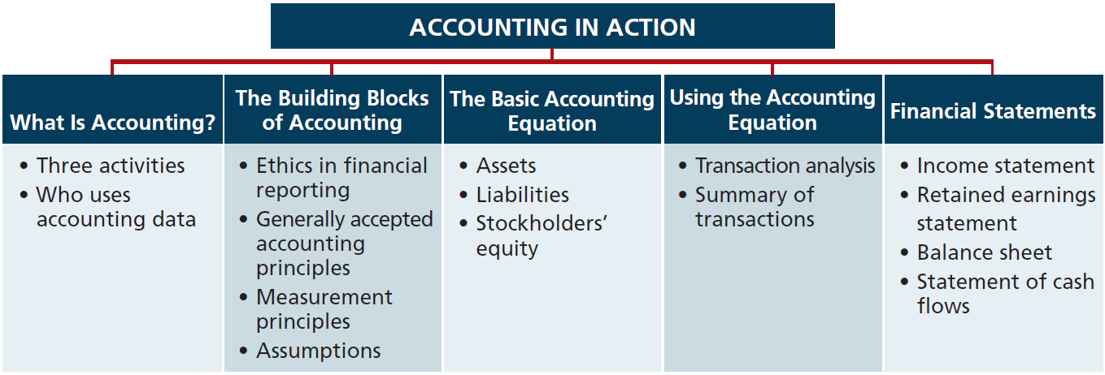

**Accounting** is the information system that identifies (Payment of wages as expense), records, and communicates (means accounting reports) the economic events of an organization to interested users [As a business owner, knowing how to read financial statement means you really know your business.

Correction

Accounting is the information system that identifies, records, and communicates the economic events of an organization to interested users.

* **Economic events:** Such as Rent Payment – Vendor Payment – Customer Collection – Running Payroll.
* **Identifies:** what is the event, when it happened, and how much is the value.
* **Record:** classifies and summarizes economic events then book it on the books.
* **Communicate:** After booking all the economic events, Financial statements will be produced with the results of the business activity such as Profit & Loss – Balance sheet and it will be communicated to interested Users.

Three Activities of Accounting

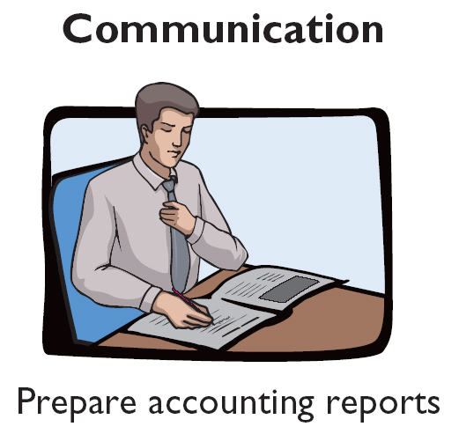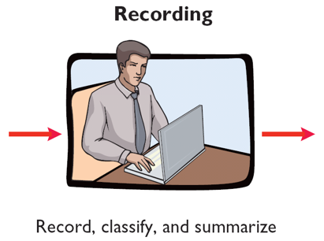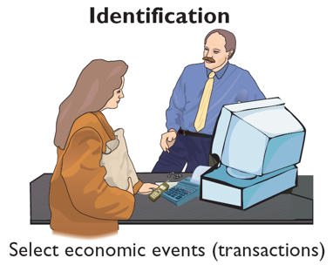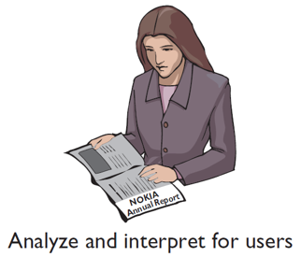

The accounting process includes the **Bookkeeping** function.

**Bookkeeping** is the process of recording financial transactions and keeping financial records. It’s small –but important- part of accounting

You should understand that the accounting process includesthe bookkeeping

function. **Bookkeeping** usually involves **only** the recording of economic events. It is

therefore, just one part of the accounting process. In total, accounting involves the entire process of **identifying**, **recording,** and **communicating** economic events

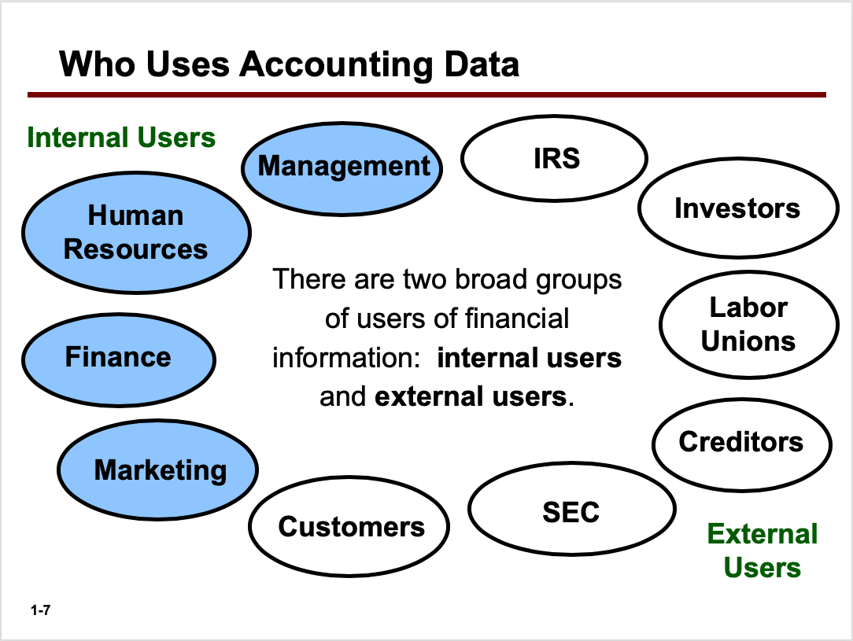

**Internal users (Inside the Organization)**

**Internal users** of accounting information are managers who plan, organize, and run the business. These include marketing managers, production supervisors, finance directors, and company officers. In running a business, internal users must answer many important questions:

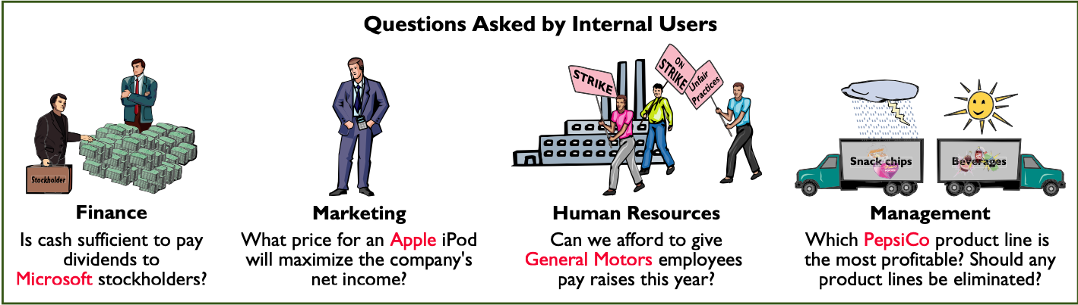

**External Users (Outside the Organization)**

* Investors: Did the company earning satisfactory income?
* Creditors: will the company be able to pay its short-term debts?

Provides economic and financial information for investors, creditors and other external users [Financial Accounting]

**Correction**

**External Users (Outside the Organization)**

**External users** are individuals and organizations outside a company who want financial information about the company. The two most common types of external users are investors and creditors.

**Investors** (owners) use accounting information to make decisions to buy, hold, or sell ownership shares of a company. For example: Investor wants to buy General Electric Stock and to get the right decision he will need some financial information like income to determine if the business is profitable and it is a good investment or not.

**Creditors** (such as suppliers and bankers) use accounting information to evaluate the risks of granting credit or lending money. For example United Airlines wants to apply for a loan to expand their operations creditors will need some financial information to determine if united airline will be able to pay back the loan when it comes due !

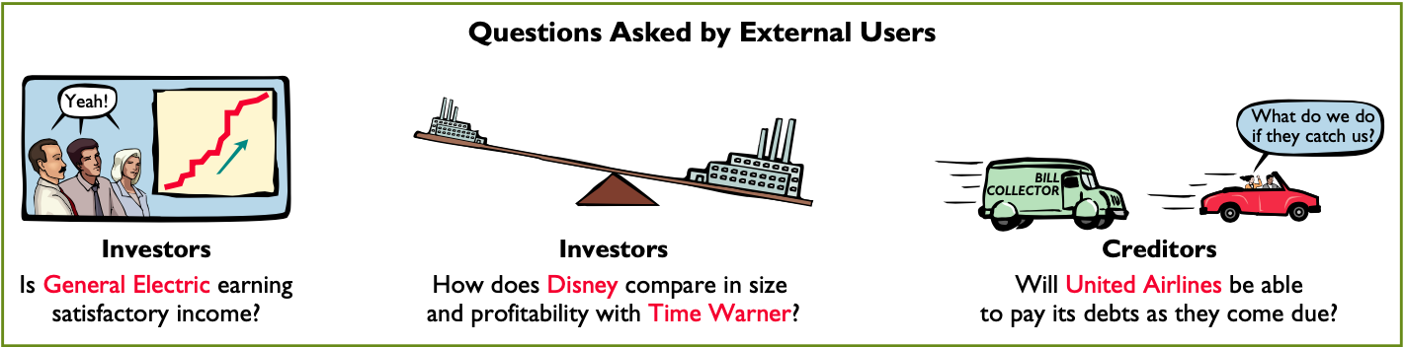

page31image5516560

**Ethics in financial reporting**

Ethics are standards of conduct by which one’s actions are judged as right or wrong, honest or dishonest, fair or not fair.

An accountant follows certain standards in reporting financial information.

**Recent Financial Scandals include: Enron, Worldcom, Healthsouth, AIG and others**

Congress passed the Sarbanes-oxley Act of 2002 to reduce unethical corporate behavior and decrease the likelihood of future corporate scandals.

**GAAP (Generally Accepted Accounting principles):** standards developed by the accounting professions that are generally accepted and universally practiced.

**Measurement principles**

GAAP generally uses one of two measurement principles

* Cost Principle (or historical cost principle) dictates that company record assets at their cost not only at the time the asset is purchased but also over the time the asset is held.

EX: X COMPANY purchases land for $300000 the company initially reports it in its accounting records at $300000. By the next year, the fair value has increased to $400000. Under cost principle, it continues to report the land at $300000.

* Fair Value Principle states that assets and liabilities should be reported at fair value (the price received to sell an asset or settle a liability)

Cost easily verified, whereas market value is often subjective.

Fair value information may be more useful than historical cost for certain types of assets and liabilities.

**Assumptions**

Monetary unit assumption: include in the accounting records only transaction data that can be expressed in money terms (it’s vital to applying the cost principle)

Economic entity assumption: requires that the activity of the entity be kept separate and distinct from the activities of its owner and all other economic entities.

Forms of business ownership

|  |  |  |
| --- | --- | --- |
| Proprietorship | Partnership | corporation |
| Business owned by one person | **Business owned by two or more persons(partners)** | Ownership divided into transferable shares of stocks |
| Often small service-type business and the owner is manager | **Often retail and service-type business** | Separate legal entity organized under state corporation law. |
| The owner receives any profits, suffers any losses and is personally liable for all debts of the business (No legal distinction) | **Typically a partnership agreement (written or oral) sets forth such terms as initial investment, duties of each partner, division of net income(net loss)** | Holders of the shares (stock holders) enjoy limited liability.  -They aren’t personally liable for the debts of the corporate entity.  -Stockholders may transfer all or part of their ownership shares to other investors at any time |

**The Basic Accounting Equation**

|  |
| --- |
| **Assets= Liabilities+ owner’s equity** |

Assets: the resources a business owns.

Provides future service or benefit [cash, Equipment, Supplies, etc.]

Assets are claimed by both creditors and owners

Claims of creditor must be paid before ownership claims

Liabilities: claims of those to who company owes money (creditors)

Claims against assets (debts and obligations)

Creditors- party to whom money is owed [Accounts payable, Notes payable, etc.]

Owner’s equity: ownership claim on total assets

Referred to as residual equity

Capital, Drawings, etc. [proprietorship and partnership]

**Owner’s Equity**

Owner’s equity= Total assets- Total liabilities

**Increase in owner’s equity**

* Investments by owner: are the assets the owner puts into the business. [Recorded in owner’s capital]
* Revenues are the gross increase in owner’s equity resulting from business activities entered into for the purpose of earning income.

Common sources of revenue are Sales, fees, services, commissions, interest, dividends, royalties and rent.

**Decreases in owner’s equity**

* Drawings: any owner may withdraw cash or other assets for personal use. Drawings decrease owner’s equity
* Expenses are the cost of assets consumed or services used in the process of earning revenue. They are decreases in owner’s equity that result from operating the business.

Common expenses are salaries expense, rent expense, utilities expense, tax expense, etc.

|  |
| --- |
| Basic equation Assets= Liabilities + owner’s equity |
| Expanded equation Assets= Liabilities + owner’s capital – owner’s drawings + Revenues - Expenses |

**Using the accounting equation**

**Transactions** are business’s economic events recorded by accountants

* It may be external or internal.
* Not all activities represent transactions [hiring employees, answering the telephone, talking with customers and placing merchandise orders].
* Each transaction must have a dual effect on the accounting equation. For example, if an asset is increased, there must be a corresponding: (1) decrease in another asset, or (2) increase in a specific liability, or (3) increase in owner’s equity.

**Transaction Analysis**

**Transaction (1),** **Investment by Owner**. Ray Neal decides to open a computer programming service which he names Softbyte. On September 1, 2012, he invests $15,000 cash in the business. This transaction results in an equal increase in assets and owner’s equity.

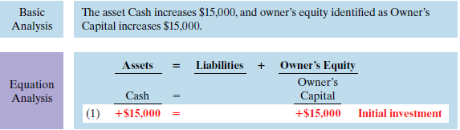

Note that the investments by the owner do not represent revenues, and they are excluded in determining net income. Therefore it is necessary to make clear that the increase is an investment (increasing Owner’s Capital) rather than revenue.

**Transaction (2).** **Purchase of Equipment for Cash**. Softbyte purchases computer equipment for $7,000 cash. This transaction results in an equal increase and decrease in total assets, though the composition of assets changes. Cash decreases $7,000, and the asset Equipment increases $7,000. The specific effect of this transaction and the cumulative effect of the first two transactions are:

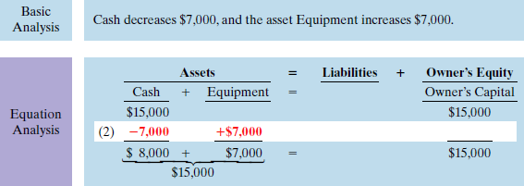

Observe that total assets are still $15,000. Neal’s equity also remains at $15,000, the amount of his original investment.

**Transaction (3).** **Purchase of Supplies on Credit**. Softbyte purchases for $1,600 from Acme Supply Company computer paper and other supplies expected to last several months. Acme agrees to allow Softbyte to pay this bill in October. This transaction is a purchase on account (a credit purchase). Assets increase because of the expected future benefits of using the paper and supplies, and liabilities increase by the amount due Acme Company.

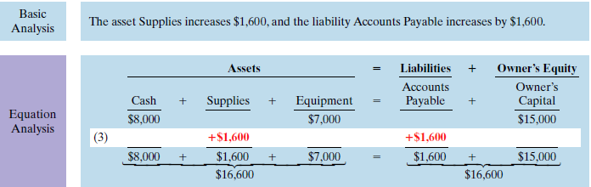

Total assets are now $16,600. This total is matched by a $1,600 creditor’s claim and a $15,000 ownership claim.

**Transaction (4).** **Services Provided for Cash**. Softbyte receives $1,200 cash from customers for programming services it has provided. This transaction represents Softbyte’s principal revenue-producing activity. Recall that revenue increases owner’s equity.

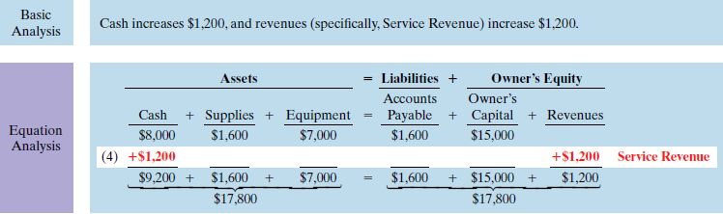

The two sides of the equation balance at $17,800. Service Revenue is included in determining Softbyte’s net income.

**Transaction (5).** **Purchase of Advertising on Credit**. Softbyte receives a bill for $250 from the Daily News for advertising but postpones payment until a later date. This transaction results in an increase in liabilities and a decrease in owner’s equity. The specific categories involved are Accounts Payable and expenses (specifically, Advertising Expense). The effect on the equation is:

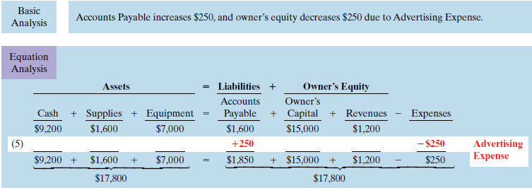

The two sides of the equation still balance at $17,800. Owner’s equity decreases when Softbyte incurs the expense. Expenses are not always paid in cash at the time they are incurred.

**Transaction (6).** **Services Provided for Cash and Credit**. Softbyte provides $3,500 of programming services for customers. The company receives cash of $1,500 from customers, and it bills the balance of $2,000 on account. This transaction results in an equal increase in assets and owner’s equity.

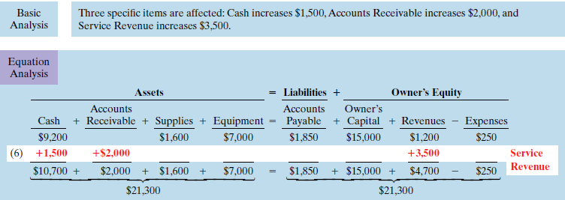

Softbyte earns revenues when it provides the service, and therefore it recognizes $3,500 in revenue. In exchange for this service, it received $1,500 in Cash and Accounts Receivable of $2,000. This Accounts Receivable represents customers’ promise to pay $2,000 to Softbyte in the future.

**Transaction (7).** **Payment of Expenses.** Softbyte pays the following expenses in cash for September: store rent $600, salaries and wages of employees $900 and utilities $200. These payments result in an equal decrease in assets and expenses. Cash decreases $ 1,700 and the specific expense categories (Rent Expense, Salaries and Wages Expense, and Utilities Expense) decrease owner’s equity by the same amount. The effect of these payments on the equation is:

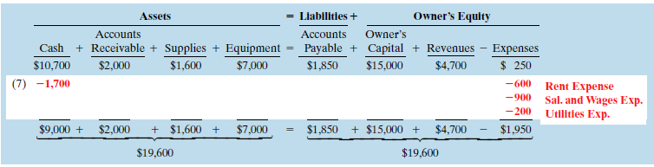

The two sides of the equation now balance at $19,600. Three lines in the analysis indicate the different types of expenses that have been incurred.

**Transaction (8).** **Payment of Accounts Payable**. Softbyte pays its $250 Daily News bill in cash. The company previously [in Transaction (5)] recorded the bill as an increase in Accounts Payable and a decrease in owner’s equity.

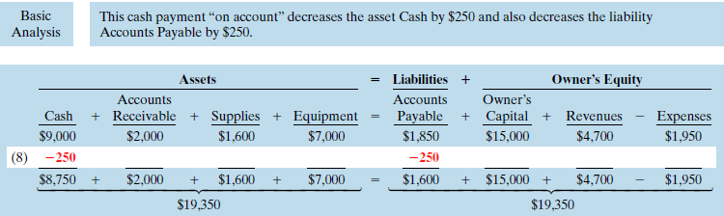

Observe that the payment of a liability related to an expense that has previously been recorded does not affect owner’s equity. The company recorded this expense in Transaction (5) and should not record it again.

Transaction (9). **Receipt of Cash on Account.** Softbyte receives $600 in cash from customers who had been billed for services [in Transaction (6)]. This does not change total assets, but it changes the composition of those assets.

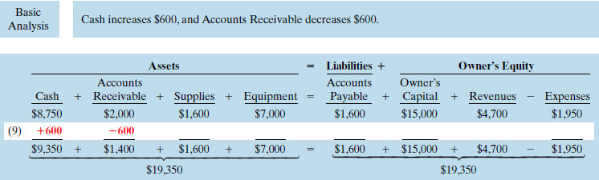

Note that the collection of an account receivable for services previously billed and recorded does not affect owner’s equity. Softbyte already recorded this revenue in Transaction (6) and should not record it again.

Transaction (10). **Withdrawal of Cash by Owner.** Ray Neal withdraws $1,300 in cash from the business for his personal use. This transaction results in an equal decrease in assets and owner’s equity. Both Cash and Owner’s Drawings decrease $1,300

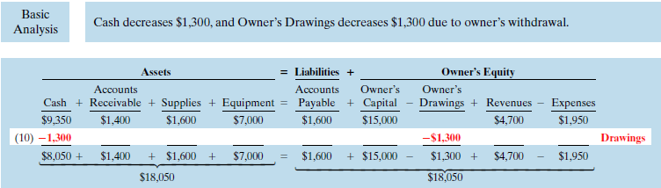

Observe that the effect of a cash withdrawal by the owner is the opposite of the effect of an investment by the owner. Owner’s drawings are not expenses. Expenses are incurred for the purpose of earning revenue. Drawings do not generate revenue. They are a disinvestment. Like owner’s investment, the company excludes owner’s drawings in determining net income.

**Summary of Transactions**

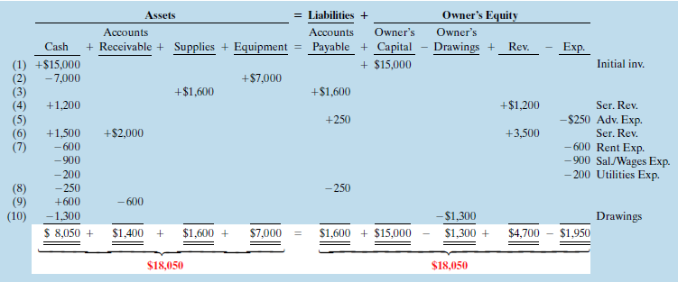

1. Each transaction is analyzed in terms of its effect on:

(a) The three components of the basic accounting equation.

(b) Specific items within each component.

2. The two sides of the equation must always be equal.

**Financial Statements**

Companies prepare four financial statements from the summarized accounting data:

1. An income statement presents the revenues and expenses and resulting net income or net loss for a specific period of time.

2. An owner’s equity statement summarizes the changes in owner’s equity for a specific period of time.

3. A balance sheet reports the assets, liabilities, and owner’s equity at a specific date.

4. A statement of cash flows summarizes information about the cash inflows (receipts) and outflows (payments) for a specific period of time.

**Income Statement**

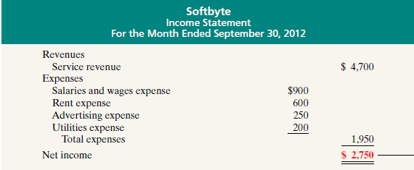

The income statement reports the revenues and expenses for a specific period of time.

**Net income** results when revenues exceed expenses.

**Net loss** occurs when expenses exceed revenues.

Note that the income statement does not include investment and withdrawal transactions between the owner and the business in measuring net income.

**Owner’s Equity Statement**

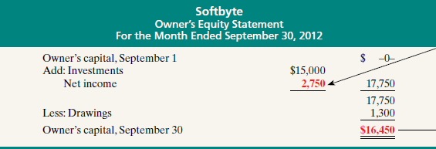

The owner’s equity statement reports the changes in owner’s equity for a specific period of time. The time period is the same as that covered by the income statement.

The first line of the statement shows the beginning owner’s equity amount (which was zero at the start of the business). Then come the owner’s investments, net income (or loss), and the owner’s drawings. This statement indicates why owner’s equity has increased or decreased during the period.

**Balance Sheet**

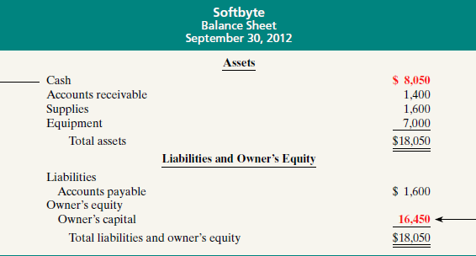

Balance sheet reports the assets, liabilities, and owner’s equity at a specific date. Observe that the balance sheet lists assets at the top, followed by liabilities and owner’s equity. Total assets must equal total liabilities and owner’s equity

**Statement of Cash Flows**

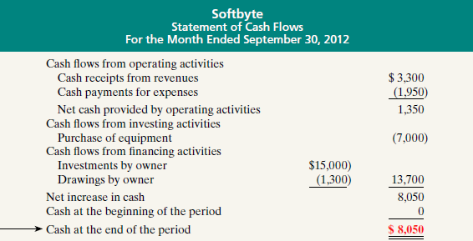

The statement of cash flows provides information on the cash receipts and payments for a specific period of time. The statement of cash flows reports

(1) the cash effects of a company’s operations during a period

(2) its investing transactions

(3) its financing transactions

(4) the net increase or decrease in cash during the period,

(5) the cash amount at the end of the period.

Reporting the sources, uses, and change in cash is useful because investors, creditors, and others want to know what is happening to a company’s most liquid resource. The statement of cash flows provides answers to the following simple but important questions.

1. Where did cash come from during the period?

2. What was cash used for during the period?

3. What was the change in the cash balance during the period?